**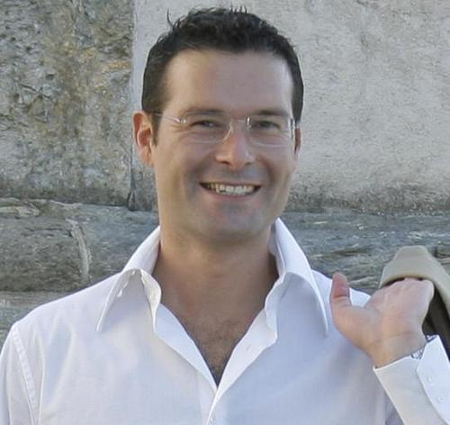**

**Andrea Gigli**

Date of birth: 19-12-1974

Living in Florence (IT)

Nationality: Italian

**Contacts**

[andrgig@gmail.com](mailto:andrgig@gmail.com)

Phone +39 349 3134 558

<https://about.me/andrea.gigli>

**Education**

* **[(2014-2015) Master in Big Data Analytics and Social Mining](http://www.sobigdata.eu/?q=master/bigdata/attivita)** @ Dept. Computer Science, University of Pisa. GPA: **A+**.
* **(2006-2011) Degree in Sociology** @ University of Florence (IT)
* **(2000-2003) PhD in Applied Statistics** @ University of Florence (IT).
* **(1999-2000) MSc in Quantitative Finance** @ University of Turin (IT). Majors: Finance, Stochastic Calculus, Econometrics, Numerical methods.

GPA: **A+ with distinction**.

* **(1993-1998) Degree** in **Economics** @ University of Siena (IT). Majors: Economics, Econometrics, Finance. GPA: **110 cum laude.**

**Foreign Languages**

* English: fluent.
* French: basic knowledge.

**Working Tools**

[Murex](http://www.murex.com/home.php): excellent; [Python](https://www.python.org/downloads/release/python-279/): very good; [Spark (Big Data framework)](http://spark.apache.org/): good; [ExcelVBA](http://en.wikipedia.org/wiki/Microsoft_Excel" \l "VBA_programming) (automation): excellent; [Matlab](http://www.mathworks.com/) (numerical analysis): good; [R](http://www.r-project.org/) (Machine Learning): good; [E-views (forecasting)](http://www.eviews.com/home.html): good; [Bloomberg](https://bba.bloomberg.net/) & Reuters: excellent.

**Other interests:**

Coach @ Italian Volleyball Federation.

|  |
| --- |
| **Master in Big Data @ Dept. Computer Science and Italian National Research Centre, Pisa** |
| I entered the [MSc in Big Data Analysis and Social Mining](http://www.sobigdata.eu/?q=master/bigdata/attivita) in 2014. Here I experienced new ways of coding in Python, R and Spark to extract value from data using machine learning, web scraping, customer profiling, recommendation systems, social networks analysis, geo-referenced data, weblog mining, natural language processing, sentiment analysis and visualization techniques. I dealt with Big Data using [Hadoop](https://hadoop.apache.org/) and [Spark](http://spark.apache.org/) framework (HDFS, Map Reduce, Hive, pySpark, MLlib, Impala mainly) and I worked on [AxWave](http://www.axwave.com/)’s dataset in order to produce actionable insights for business development. Some projects are posted [here](http://www.slideshare.net/andrgig). |
| **CVA Director and Special Projects Manager @ MPS Capital Services** Reports to: Head of Capital Markets |
| **June 2012– today –** [www.mpscapitalservices.it](file:///C:\Users\claudia.martino\Downloads\www.mpscapitalservices.it)  In the last years I’ve been in charge to set up the CVA Desk in MPSCS. The project redesigned the valuation workflow from Client Rating Assessment to Pricing and Risk Management of FX & Interest Rate Products. The implementation required to build a **cross-department repository of quantitative and qualitative** **data**. Those data come from different sources, feeding both **valuation models** for pricing new deals or valuating booksand **business dashboards** for measuring relevant **credit KPIs**. My role covered the designing, testing and validation of the data-model implementation, in addition to departments engagement and management understanding**.** Today I manage thedesk and its **continuous improvement**. Since February 2014 I’ve been entitled **Stream Leader** for the whole front-office system upgrade (from Murex 2.11 to Murex 3.1, ending in July 2015, worth 10mios euro) and in charge of projects supervision in the field of Big Data Analysis, Business Model Innovation. |
| **Interest Rate Volatility Desk Director @ MPS Capital Services** Reports to: Head of Capital Markets |
| **February 2009 – 2012 –** [www.mpscapitalservices.it](file:///C:\Users\claudia.martino\Downloads\www.mpscapitalservices.it)  Leading a 4 people team, I was in charge of **P&L results and business development** of the Interest Rate Volatility Desk. Beside managing actively market risk and monitoring the team work, during this period I followed the implementation of several processes and system improvements in order to keep the business unit aligned with new market practices and regulatory requirements after 2008 crisis. My role required to **negotiate task assignments and interact with other Directions**, **sharing strategies and goals** with and within working groups and **reporting** developments to the management. |
| **Interest Rate Volatility Desk @ MPS Finance** Reports to: Head of Interest Rate Desk |
| **February 2007 – 2009 –** [www.mpscapitalservices.it](file:///C:\Users\claudia.martino\Downloads\www.mpscapitalservices.it)  I was in charge of **taking,** **measuring and managing risks for EURO trading books** and supporting the development of new **pricing models**. On a daily basis I kept relations with Sales, Structuring, Quants, Asset & Liability Management Departments in order to define and plan the product development. In the same period I designed and managed as **Project-Manager** the implementation of a platform to perform execution and trade processing automation. |
| **Trader @ MPS Finance** Reports to: Head of Interest Rate Desk |
| **February 2003 – 2007–** [www.mpsfinance.it](http://www.mpsfinance.it)  My responsibilities covered mainly the pricing and trading of interest rate product, the development of a derivatives pricing user-friendly tool for Sales and the development of a proprietary platform to quote bonds prices in the market and managing post-trade events. |
| **Teaching and Research Assistant in Finance @ University of Lugano (CH)** |
| **September 2001 – February 2003 –** [www.istfin.eco.usi.ch](file:///C:\Users\claudia.martino\Downloads\www.istfin.eco.usi.ch)  I attended PhD courses in Finance while developing **pricing models** for Electricity Derivatives and **statistical risk measures** using High Frequency Data. During my stay, I developed a margin-call pricing model for the **London Clearing House** and I was awarded with a research grant from the Swiss National Foundation to undertake 6 moths research at the **University of Technology of Sydney**. |
| **Quantitative Analyst @ Prometeia (Bologna)** |
| **February 2001 – August 2001 –** [www.prometeia.com](file:///C:\Users\T000524\Desktop\www.prometeia.com) I developed pricing models for equity derivatives pricing. |
| **Other Activities** |
| **Founder and Project Manager @ Startup Saturday Europe** |
| **December 2012 – today**  [Startup Saturday Europe](http://www.startupsaturday.it) is a European nonprofit organization. Its mission is to favor **Collaborative Networking** among Innovation Stakeholders. As President and co-founder, I support startups in defining the **business development strategy,** doing **market analysis** and applying **lean methods** in their organizations. |